How to register in MeDir...

Online entry forms are available for direct inputs and for updating of records
Further notes on how to complete the entry form:
- Section 1 requires details on Individual and Institutional Information:
Name; Working Language; Job Title & Type; Organisation Name, Acronym and Type; Department; Contact details; URL

- Section 2 requires details on Research Information:
Activities – important: use keywords to describe your main activities;
DO NOT write this information in sentence form
Geographic Group/s– select the region/s in which you carry out your main activities
Geographic Descriptors – specify any particular areas within that region
Environment – select the main environment/s covered by your research
Citations – list the 10 most recent/most important publications by using the format shown in the sample

If you have any difficulties please contact the MedGOOS Secretariat.

Contacts for MedGOOS

MedGOOS Executive Secretary
Aldo Drago
MedGOOS Secretariat
IOI-Malta Operational Centre
University of Malta
c/o 36, Old Mint Street, Valletta
MALTA
Tel: +356 21232493
Fax: + 356 21232493

e-mail: aldo.drago@um.edu.mt
Chairperson
Silvana Vallerga
CNR&IMC
Localita’ Sa Mardini 09170
Torregrande-Oristano
ITALY
Tel: +39 0783 22027/22136/22032
Fax: +39 0783 22002

e-mail: vallerga@nameserver.ge.cnr.it

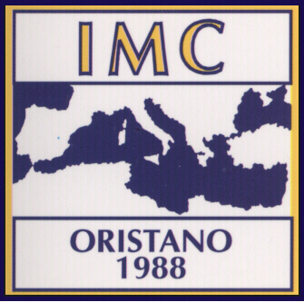

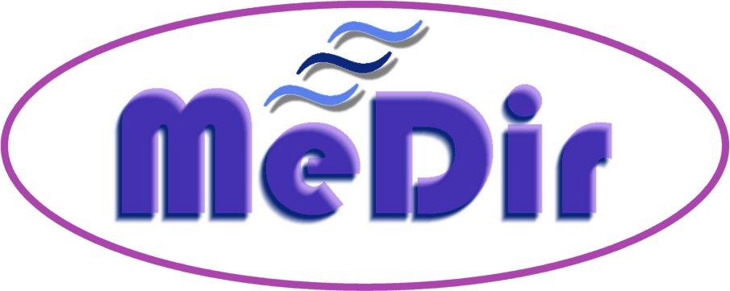

A DIRECTORY OF MARINE SCIENTISTS AND PROFESSIONALS WORKING IN THE MEDITERRANEAN REGION

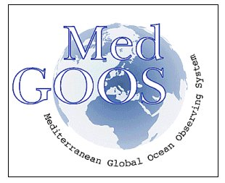

A MedGOOS Initative

What is MeDir…

The realisation of a regional approach in marine research and in operational ocean observations and forecasting in the Mediterranean calls for strong linkages and for integration of efforts, knowledge, programmes and resources among countries and across the whole basin. The networking between institutions, between scientists, and with managers and end-users in general is the means to achieve such integration. This is indeed a primary goal within the MedGOOS implementation strategy.
In support to this need, the MedGOOS Secretariat has embarked on an initiative to set up a directory of marine scientists and professionals working in the Mediterranean region (MeDir). This free and searchable database is available on WWW as a service to the whole scientific community of the Mediterranean. MeDir can be accessed at http://ioc2.unesco.org/medir. MeDir is the first phase of a database, of much wider scope, to be established in the near future under the Mediterranean network to Assess and upgrade Monitoring and forecasting Activity in the region (MAMA).
The MeDir directory is based on the Global Directory of Marine (and Freshwater) Professionals, GLODIR, which is a database developed and maintained by the Intergovernmental Oceanographic Commission of UNESCO (IOC) under the auspices of the IODE's Group of Experts on Marine Information Management (GE-MIM).
MeDir is a subset of GLODIR and provides an enhancement to it by reaching out to as many individuals and institutions specifically in the Mediterranean.

How to help us…

- Should you already have your entry in GLODIR kindly confirm the details of your present record by filling the online MeDir form as a new entry
- Report to us your entry by email on aldo.drago@um.edu.mt or by fax on +356 21232493
- If possible circulate this information to your colleagues in your organisation and within your circle of contacts or else send us their details so that we can contact them directly

