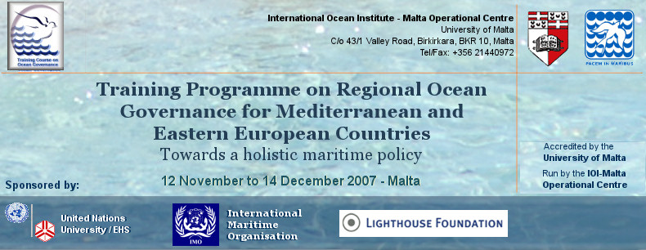
Application for the
TRAINING PROGRAMME ON REGIONAL OCEAN GOVERNANCE FOR MEDITERRANEAN AND EASTERN EUROPEAN COUNTRIES
12th Nov – 14th Dec 2007, Malta

In order to apply for the TRAINING PROGRAMME you will need to complete the following steps:

1 Complete the following forms on the checklist and attach copies of any certificates required.

Application Form pgs 2 – 6
Nomination Form pg 7
Medical Form pg 8

- POST/MAIL the original completed application by 15 September 2007 to:

Course Coordinator, IOI Malta Operational Centre
University of Malta
c/o 43, Flat 1, Valley Road, B’Kara,
MALTA

- Additionally you should also email your application by 15 September 2007 as follows:

Course Coordinator, IOI Malta Operational Centre
Tel / Fax. +356 21 440 972
E-Mail: ioimaltacourse@capemalta.net

- Please also refer to the Training Course Web page for further information and any updates.

http://www.capemalta.net/ioimoc/course2007/

Late or incomplete applications will not be considered.

Application Form

Please fill in all sections clearly in English. Complete and detailed answers are required in order to ensure the most appropriate selection of candidates. Feel free to attach additional pages if necessary.

1 personal details
Title | Mr/ Ms/ Dr / other (please specify) _____
Family name

First name/s

Gender | M / F
Age group | 20-30 30-40 40-50 50 +
Contact address

Contact telephone number (inc country code)

Fax number

Email address

Nationality

Do you need a visa to enter Malta? (Visa requirements for entry into Malta can be obtained from http://www2.mfa.gov.mt/pages/main.asp?sec=83 Please ensure that you check your status carefully

Y / N

2 language skills
First language

Other languages spoken / understood

3 english language proficiency
Reading | Excellent / Good / Basic
Writing | Excellent / Good / Basic
Speaking | Excellent / Good / Basic
Have you ever taken a standardised English language test (TOEFL, IELTS, MELAB)? Y/N
If Yes state which test and give score and date:

4 employment history (beginning with present or most recent employer and listing relevant previous positions)
Position title

Employer’s name and address and nature of business

Years of service (from – to)

Description of duties

Position title

Employer’s name and address and nature of business

Years of service (from – to)

Description of duties

Position title

Employer’s name and address and nature of business

Years of service (from – to)

Description of duties

Position title

Employer’s name and address and nature of business

Years of service (from – to)

Description of duties

5 post-secondary education (starting with most recent)*
Dates (mm/yyyy)  From - To | Name of Institution | Qualifications obtained
*Please attach copies of certificates obtained.

6 Have you ever been awarded a scholarship? If yes, please give details.

7 Have you previously attended an IOI Training Programme? If yes, please give details.

8 Have you written or contributed to relevant publications? If yes, please give details. (Do not attach)

9 membership in relevant professional institutions
Name of institution | Membership status | Membership period (yyyy)
10 Please show how your application meets the person specification and give a detailed description of the practical use you will make of this training on your return home in relation to the responsibilities you expect to assume and the conditions existing in your country in your field of work.

11 funding

Please specify whether you are applying for this course

as a fully self-funded / sponsored participant
Please attach proof of sponsorship.

OR
as a participant to be funded by IOI

on a full scholarship

on a partial scholarship ( to cover flights, accommodation and meals OR course fee)

Please note that fully self funded / sponsored participants will be given preference. Kindly refer to the section on fees and funding on the course website or contact the course coordinator for more detail.

Kindly also note that successful applicants will be required to obtain adequate medical and other insurance cover for their entire stay in Malta in connection with the training course. This expense is not covered by the scholarship package and participants are to make the necessary arrangements and cover these costs personally.

I certify that my statements in answer to the foregoing questions are true, complete and correct to the best of my knowledge

__________
Candidate’s signature Date

Participant Nomination Form

To be completed by a senior official of the nominating Government entity, university or equivalent educational institution, national or regional organisation.

______________________________________________ (name of nominating organisation)

nominates

______________________________________________ (name of nominee)

as a candidate for the training course on Regional Ocean Governance for Mediterranean and Eastern European Countries 2005 and certifies that:

- all information supplied by the nominee in the attached form is complete and correct;
- the nominee has adequate knowledge, appropriately tested, of the English language; and
- the absence of the nominee from his/her place of work/study during his/her attendance at the course would not have any adverse effect on his/her status, seniority, salary, pension or similar rights.

Name of Nominator

Postal address

Email address

Signature: | Date: | Official seal:

Medical Form
To be completed by a registered medical practitioner after thorough clinical and/or laboratory examination. The IOI reserves the right to require the candidate to undergo a further medical examination before his/her course participation.

Name of Candidate:

Date of Birth: Male/Female

Is the person examined at present in good health and enjoying full working capacity?

Is the person examined able, physically and mentally, to carry on intensive study abroad?

Does the person examined have any infectious or other diseases (for example, tuberculosis, trachoma, malaria, AIDS), which could present risks for the candidate and/or his/her contacts during the course? If so, please provide details.

Does the person examined have any condition(s) which might require treatment during the course? If so, please provide details. It is important to note that the IOI does NOT provide any kind of health insurance or aid cover to participants. Participants would find medical care in Malta expensive.

Name of Examining Physician (Please print.) | Signature of Examining Physician

Address of Examining Physician

___________________
Date

